New Patient | Column: HYG  ProvID: NEW  Reason: Initial – NP Child NoX  30 minutes  Only for patients who have not been seen by any of our brands before. Even if a child has not been seen in several years, they are not a new patient.  Ask probing questions  - “Are you calling for general dentistry or orthodontics?”  - “Have any of your children been to any of our offices before?”  - “Has the child had a cleaning in the last six months?”  - “What kind of CDH - Insurance does the child have?”  - If the insurance provided is not in network, advise the caller that the insurance is not in network and treatment would not be covered under in-network benefits.  - We offer a new patient special of $99 (not for referrals or 2nd opinions). This includes a full comprehensive exam, cleaning, fluoride, and x-ray. An ABN (Advance Beneficiary Notice) must be signed by the parent prior to services being rendered. This form states that they are responsible for all costs.  - Any other questions on payments should be directed to the office. If unable to reach the office, send an AIF.  - Probe if the patient is being referred. If they are, schedule as a 2nd opinion.  Parent / legal guardian must be present at the first appointment. If the legal guardian is not the parent, physical court documentation must be with them at the time of the visit.  New Patient Paperwork will be sent to their email on file and as a text link in NexHealth. If they do not complete it prior to the appointment, they must arrive 20-30 minutes early to complete it in office.  If the new patient is having an emergency, schedule as an emergency instead of new patient.  Schedule siblings side-by-side when possible. If the patient has special needs, include a note of any conditions requests for accommodations.  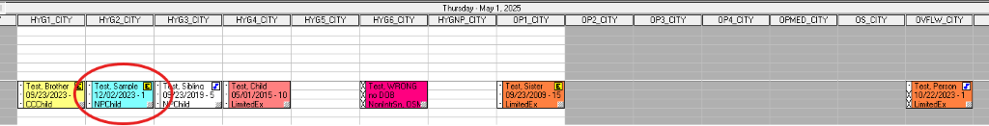

Hygiene | Column: HYG  ProvID: Recall  Reason: Initial – RC Child NoX  30 minutes  45 minutes – Springfield (if there is an alert for behavior, previous calculus build-up, braces, or other impacting factors)  Hygiene. Six-month Recalls  Check the patient’s last visit notes in Clinical Notes to determine the date of the last hygiene appointment. The Cont. Care in the chart is not always accurate.  If the patient will not be brought by the parent or legal guardian:  - The adult must be at least 21 years old.  - The adult must be listed on the HIPAA approved list of persons permitted to escort the patient to appointments.  - Include a note in the appointment and in the Clinical Notes of who will be bringing the patient.  Use the Six Months button in the scheduling book to determine when the patient is due. Simply enter the date the patient was last seen and click the button in the lower right corner. Hygiene may be scheduled from that day forward.  Schedule siblings side-by-side when possible. If the patient has special needs, include a note of any conditions requests for accommodations.  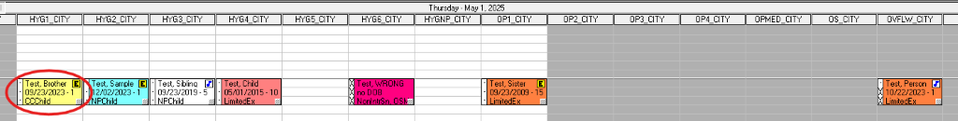
OWM | No longer used by CDH. Schedule normally regardless of age.

